https://wordpressadminpanel.com/admin-panel/what-is-wordpress-admin-panel/:
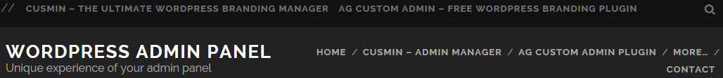
What is WordPress Admin Panel? (wordpressadminpanel.com)

Contents
What is WordPress Admin Panel? 2
How to Access It? 3
What is Admin Menu? 3
WordPress Admin Bar 3
What is Dashboard Page? 4
Customize Admin Panel with AG Custom Admin pligin 4

What is WordPress Admin Panel?
This is the place where you can do all WordPress CMS management. It is accessible only by authenticated users.
Here is an example of an admin panel and its areas:
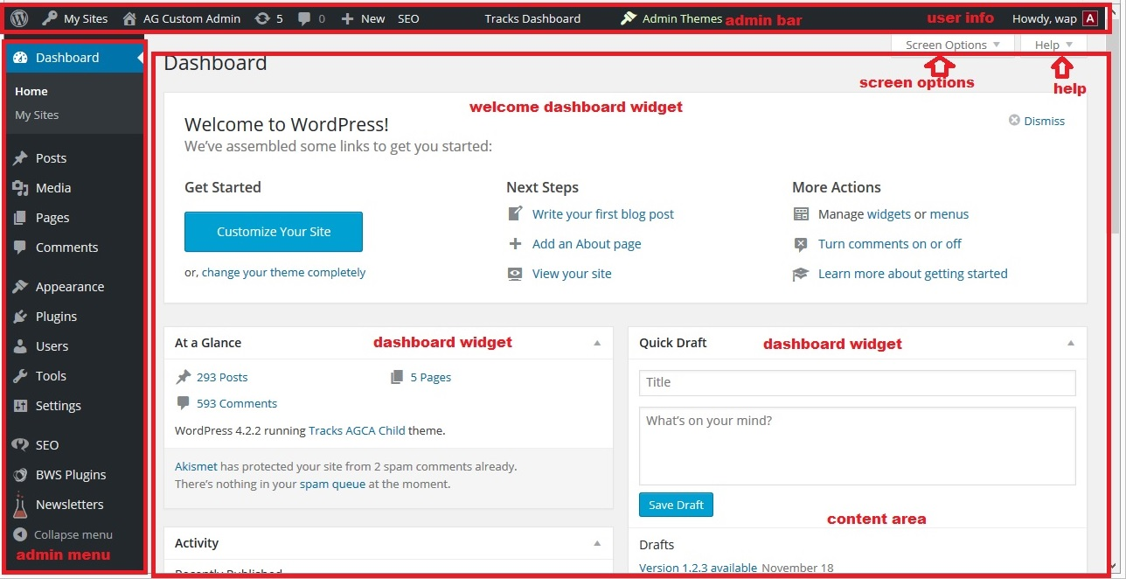
WordPress admin panel
As we can see from the previous image, WordPress Admin panel contains following parts:
- Admin Menu: is main navigation in the admin panel. Choose a menu item or submenu item to navigate to specific page
- Admin Bar: is WordPress bar on top, and can contain some useful information and links. It shows for authenticated users only.
- User Info: shows information about currently logged in user on admin bar. It’s located on the top right. On mouseover, it shows some more information about user’s profile and the button for logging out.
- Content Area: is the central part of the WordPress admin panel where almost all data is shown. Different pages have different content, but top admin bar and left navigations are almost always the same.
- Screen Options: are giving some additional options to hide/show some elements on pages. If you can’t find something on a page, try going here first to see if that element is hidden in the view.
- Help: gives some useful links to WordPress help pages.
- Dashboard Widgets: content on the dashboard pages is structured into Dashboard widgets. This way it’s very handy to move the content around or to show only the content that you actually need.
- Welcome WordPress Dashboard Widget: shows some useful information for those who use WordPress for the first time. You can easily hide it by clicking on Dismiss.

How to Access It?
To access admin panel go to example.com/wp-admin/ or example.com/wp-login page. You need to log in there with your WordPress credentials

What is Admin Menu?
Admin menu is main navigation in the admin panel. The default page is Dashboard page. By default, admin menu contains following menu items/options:
- Dashboard: default page with dashboard widgets. Contains submenus:
– Home – homepage
– Updates – for updating WordPress core and its content, themes, and plugins
– Akismet stats: default WordPress plugin
- Posts: used for posts management, adding, deleting, editing, and post category management
- Comments: used for comments management
- Appearance: used for themes management
- Plugins: here you can add, activate, delete and change settings of WordPress plugins. Each plugin contains some other useful information, like plugin authors, version etc.
- Users: one place to manage all users on your WordPress site. Add, delete, edit users, change their personal information and permission levels or roles.
- Tools: this is the place used for storing additional tools used by WordPress. Some plugins or themes can add their tools here.
- Settings: all settings are here, in one place. Here you could find also settings of installed plugins too.
- Collapse menu: choose this option to collapse admin menu. When it’s collapsed only admin menu icons are visible. This is useful when admin panel is used on devices with smaller screens: mobile phones or tablets.

WordPress Admin Bar
When a user is logged in to WordPress admin panel, on the top of the page admin bar appears. It contains useful information about currently logged in user and shortcuts to most useful options in admin panel.
WordPress Logo Icon
On the very left, there is WordPress logo icon. When clicked, it opens WordPress about page that contains some useful information about installed WordPress versions, like info about new features and improvements. On mouse over, the contextual menu appears with following menu items: – About WordPress – This is basically the same page as linked by WordPress logo icon button. – WordPress.org – is the main WordPress repository that contains all information about WordPress, downloads, forums etc – Documentation – WordPress is the one of the best organized and documented CMS’s. This site gives you almost all information about WordPress core, it’s classes, methods, libraries and all other parts. – Support Forums – if you need question, this is the first place where you look for it. WordPress is used by millions of people and it’s very likely that any question that you have is already answered. If you can’t find the answer to your question, you can always ask the new one. – Feedback – This is the place to post your ideas, questions or anything that you think might improve WordPress in future.

What is Dashboard Page?
This is default page in admin panel that opens when a user logs in. The user can define the content that he wants to see on this page. Content is grouped into widgets. You can easily hide/show only those widgets that you actually need. To hide dashboard widgets, go to Screen Options or download AG Custom Admin plugin and go to Dashboard tab.

Customize Admin Panel with AG Custom Admin pligin
Customizing of WordPress admin panel has never been so easy like it’s now with AG Custom Admin plugin. It contains dozens of different options for customizing admin panel, login page, changing colors, customizing admin menu, adding branding images etc.
In a matter of minutes, you can find what combination of settings is the best for you and your clients. You can even export those settings and apply them to all other sites you have!
With AGCA themes, you can apply custom admin panel theme with just one click of your mouse! This was never been so easy like it’s now!

All in one solution for WordPress admin panel customizations
Yes, it does exist, and it has tons of options for customization. It helps you brand your site’s backend in a way you have never imagined.
Cusmin is premium WordPress plugin that gives you almost everything you need for admin customization, starting from the custom login page, custom dashboard widgets, custom admin bar and admin menu, changing menu icons, support for multiple customizations and multiple user levels, multi-site sync and much much more.
Check out what Cusmin can do, it serves quite well professional users, so it would be definitely a good fit for your site as well!

